**Table of Content**

E-governance Implementation Scenario of Nepal 2

Current Status of e-Governance and ICT in Nepal 2

Challenges to e-Government Development 2

E-governance Implementation Scenario of South Korea 3

e-Governance Services Available in South Korea 4

Comparing E-governance Scenario of Nepal & South Korea 5

## E-governance Implementation Scenario of Nepal

Nepal is in the primary level of e-Government implementation. Nepali government has been trying to provide one-way service to the citizens, government agencies and business since last few years.

Nepal, with the collaborative effort of Korea IT Industry Promotion Agency [KIPA], has prepared a e-Government Master Plan Consulting Report [e-GMP]. This report has been prepared to lay ground work for eGovernment transformations. This master plan accommodates the following goals:

* + Establish the vision, strategy and framework for Nepal's e-Governance
  + Suggest major e-Governance projects and draw the roadmap
  + Define direction of the executing organization and restructuring legal framework

In Nepal the e-Governance implementation is new to the people. The government agencies have been pushing the total implementation of e-Governance since the past few years with the introduction of digital driving licenses and plans about the implementation of a digital national ID as a replacement for the current citizenship.

### Current Status of e-Governance and ICT in Nepal

* All 75 districts now have proper telecommunication services. STD and ISD calls can be made from anywhere and the recent involvement of telecommunications providers has provided mobile access to telecommunication.
* As of 2011, the internet penetration is at about 9.0% of the total population. This includes the users of dial-up connections, cable, wireless, and fiber optics.
* Several e-Government initiatives have begun;
  + Integrated Voters' Registration System
  + Financial Management Systems
  + District Expenditure Control System
  + Automated System for Customs Data
  + PAN Registration System
  + VAT Assessment/Collection System
  + Income Tax Assessment/Collection System
  + Revenue Accounting System etc...

### Challenges to e-Government Development

* Low level of political commitment to the implementation of services
* Very poor culture of technology. Literacy about the technology is also very limited in the government
* The development of e-Government services is mostly skewed towards the major cities only. Usually, the new services provided by the government only penetrates the capital – Kathmandu.
* 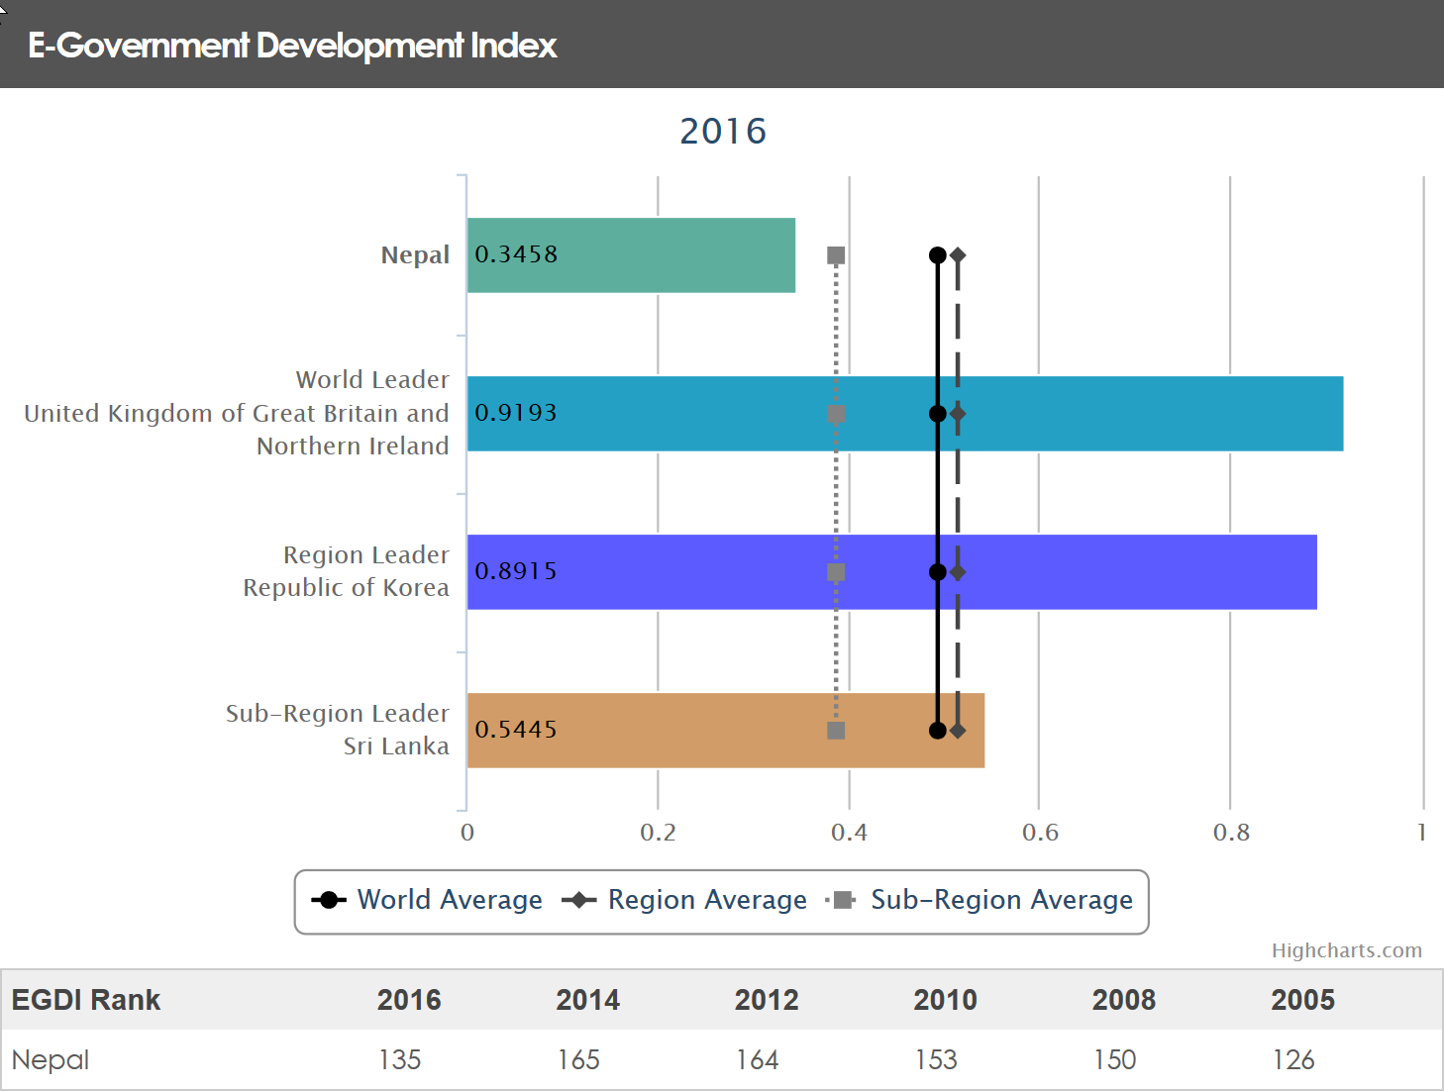

Figure 1E-Government Development Index of Nepal

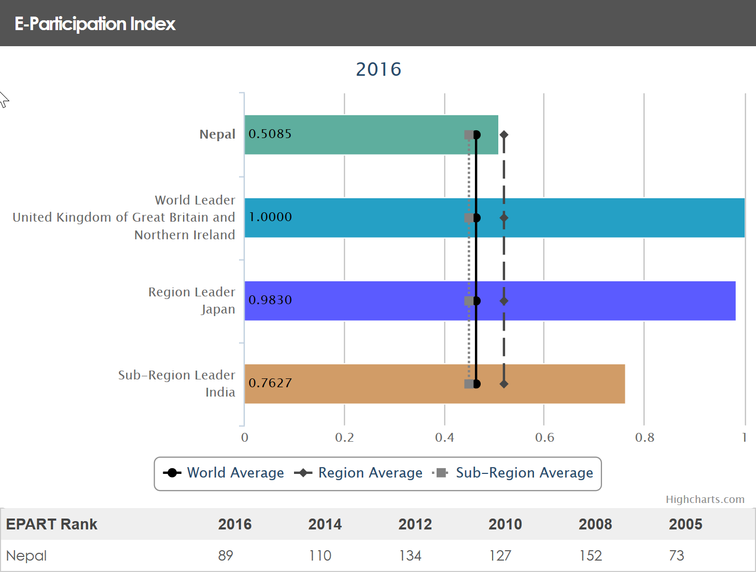

Figure 2E-Participation Index of Nepal

## E-governance Implementation Scenario of South Korea

Korea has actively pursued e-Government as a medium to make its government more competitive by leveraging the world's best information and communication technology including broadband internet.

The e-Government of Korea is recognized as one of the best in the world. As such, various e-Government systems from Korea have been exported to foreign nations. In 2010, the UN Global e-Government Survey marked Korea with the highest possible score in the categories of Online Service Index and the e-Participation Index. Korea is now promoting e-Government that is focusing on utilization and convergence by consolidating services to maximize the convenience of users and implementing a seamless digital cooperation system connecting government departments and agencies to improve the overall quality.

### e-Governance Services Available in South Korea

* Electronic Procurement Service:
  + It handles all the procurement procedures online
* Electronic Customs Clearance Service:
  + Allows sharing of logistic information among the logistics entities
* Comprehensive Tax Services:
  + Tax can be handled online
* Internet Civil Services:
  + Allows the use of administrative services through the internet
* Patent Service:
  + All patent information can be obtained online
* E-People: Online Petition and Discussion Portal:
  + Allows the involvement of people in policy-making by providing a portal for obtaining their feedbacks
* Single Window for Business Support Services:
  + Provides a wide range of information and service to support companies' business activities
* On-nara Business System:
  + It is a new business management system that is more efficient and transparent
* Shared Use of Administrative Information:
  + Allows civil service officers to process civil service requests without having to ask for documents from the applicant
* National Computing and Information Agency:
  + Operates and manages all information system of the government

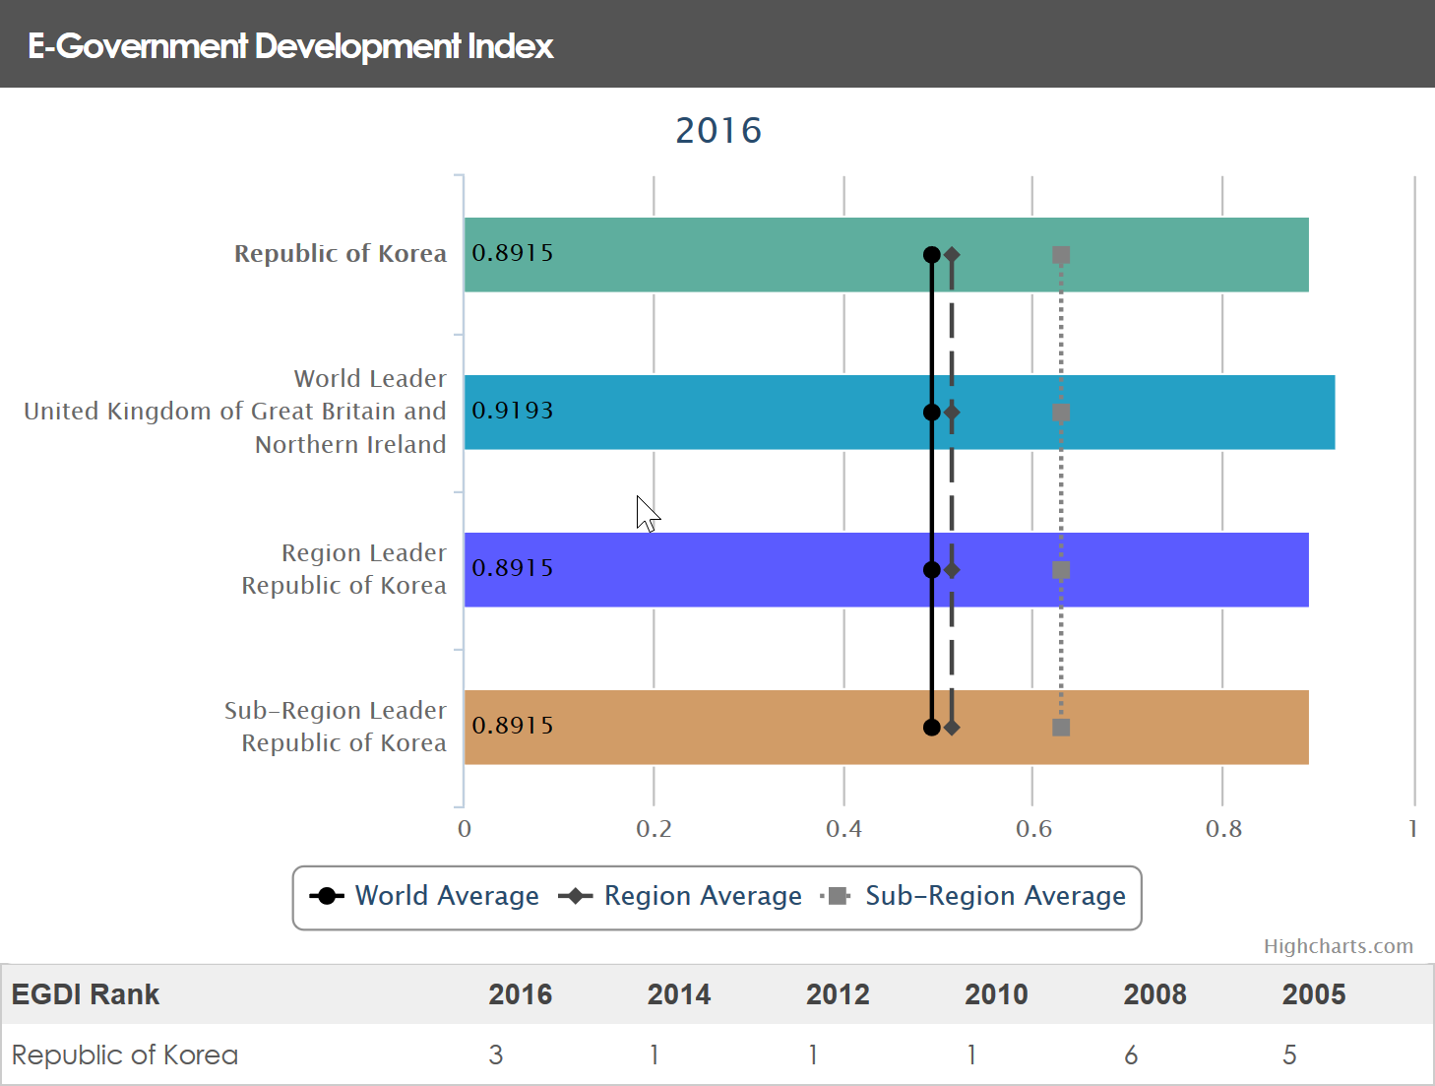

Figure 3E-Government Development Index of Korea

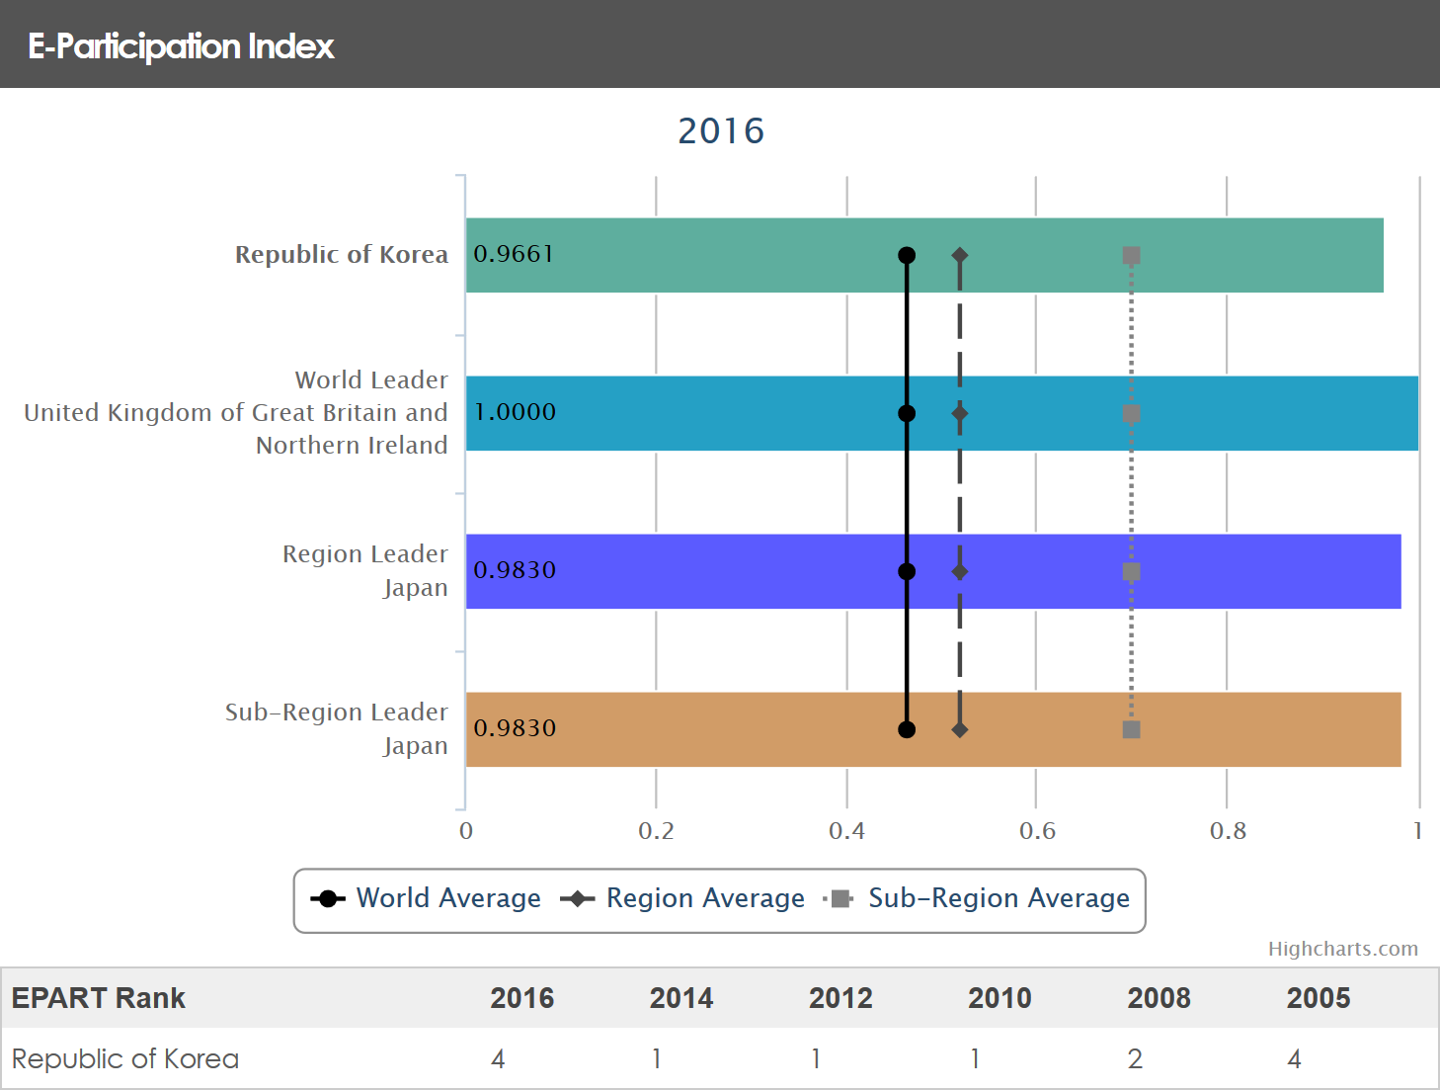

Figure 4E-Participation Index of Korea

## Comparing E-governance Scenario of Nepal & South Korea

Comparatively Nepal and South Korea are very far apart in the e-Governance scenario. Korea’s implementation of e-governance is considered one of the top ones in the world. While Nepal lies further down the list at ~150th position. During the 1990s the e-gocernment status of Nepal and South Korea was comparable but South Korea’s development rised rapidly. This resulted in South Korea rising to the top ranks while Nepal slowed down their development to a crawl.

